Key messages

- In June 2026, over 54.4 million people in 10 of the 13 countries covered by the FSNWG were estimated to be highly food insecure (IPC Phase 3 or above) and in urgent need of humanitarian assistance. Of these, close to 24.3 million were in six IGAD member states. These figures should, however, be interpreted with caution due to the significantly reduced geographic coverage of Sudan in the latest IPC analysis.
- A risk of Famine was identified in 14 areas across North Darfur, South Darfur and South Kordofan in Sudan, and in Akobo and Nyirol (Jonglei) and Luakpiny| Nasir and Ulang (Upper Nile) in South Sudan under a worst-case scenario. Across both countries, 273,019 people were estimated to be in Catastrophe (IPC Phase 5).
- Nutrition outcomes across the region remained concerning, reflecting constrained access to food, inadequate infant and young child feeding practices, and limited health and nutrition services. Of particular concern are areas of Kenya, Somalia, South Sudan and Sudan classified in a Critical (IPC AMN phase 4) or Extremely Critical (IPC AMN phase 5) acute malnutrition situation.
- The Middle East conflict continued to disrupt global
energy and fertilizer markets, increasing agricultural production and transport costs, and putting upward pressure on food prices. Food price impacts are already pronounced in several countries, including Somalia, South Sudan and Sudan.
- A persistent dry spell since April has affected many parts of the region, including Ethiopia, western Kenya and northern Uganda. Drier than usual conditions forecast between July to September across northern and western parts of the region, are heightening the risk of reduced crop and livestock production in affected areas.
- El Niño conditions are present and are expected to strengthen through the end of 2026 and persist until at least early 2027. The Indian Ocean Dipole (IOD) is expected to shift towards a positive phase in the coming months and strengthen alongside El Niño, which could intensify wetter than usual conditions in the eastern parts of the region during the October-December rainfall season.
- Ebola transmission continued in the Democratic Republic of Congo (DRC) and Uganda, with a total of 1,812 confirmed cases (1,792 in DRC and 20 in Uganda) as of mid-July.
Food insecure population estimates, as of June 2026

IPC analyses | Stressed  (IPC Phase 2) | Crisis  (IPC Phase 3) | Emergency  (IPC Phase 4) | Catastrophe  (IPC Phase 5) | Crisis or worse  (IPC Phase 3+ or equivalent)
Djibouti | 484,802 | 174,969 | 54,693 |  | 229,662
Kenya | 6,554,362 | 3,386,465 | 731,806 |  | 4,118,271
Somalia | 7,725,794 | 4,154,332 | 1,875,950 |  | 6,030,282
South Sudan | 4,033,973 | 5,276,159 | 2,485,293 | 73,306 | 7,834,758
Sudan | 1,977,719 | 3,126,748 | 2,247,617 | 199,713 | 5,574,078
Uganda | 581,016 | 432,109 | 41,259 |  | 473,368
IGAD Total | 21,357,666 | 16,550,782 | 7,436,618 | 273,019 | 24,260,419
Burundi | 4,299,231 | 1,140,137 | 0 |  | 1,140,137
CAR | 2,721,333 | 1,747,663 | 262,499 |  | 2,010,162
DRC | 53,143,861 | 22,873,371 | 3,627,949 |  | 26,501,320
Tanzania | 2,308,238 | 507,498 | 0 |  | 507,498
Total | 83,830,329 | 42,819,451 | 11,327,066 | 273,019 | 54,419,536
Source: IPC Global Support Unit (GSU) for East and Central Africa

Sector updates

Food security
High levels of acute food insecurity continued to be reported across the region. As of June, over 54.4 million people across 10 of the 13 countries covered by the FSNWG were estimated to be facing Crisis or worse (IPC Phase 3 or above) levels of acute food insecurity, including close to 24.3 million people across six IGAD member states – Djibouti, Kenya, Somalia, South Sudan, Sudan and Uganda.
Of these, about 7.4 million people were classified in Emergency (IPC Phase 4), while 273,019 others in South Sudan and Sudan were classified in Catastrophe (IPC Phase 5).
These figures should, however, be interpreted with caution and should not be taken as indicating an overall improvement in the regional food security situation as the decline in the regional caseload is primarily attributable to the partial geographic coverage of the latest IPC analysis for Sudan. The analysis covered only 56 out of 195 localities and IDP settlements, representing about 8.3 million people out of Sudan’s estimated total population of 47.5 million people.
Consequently, the regional estimates are not directly comparable with previous reporting periods and are likely underestimating the scale of acute food insecurity across the region.
Regional food security situation, as of June 2026
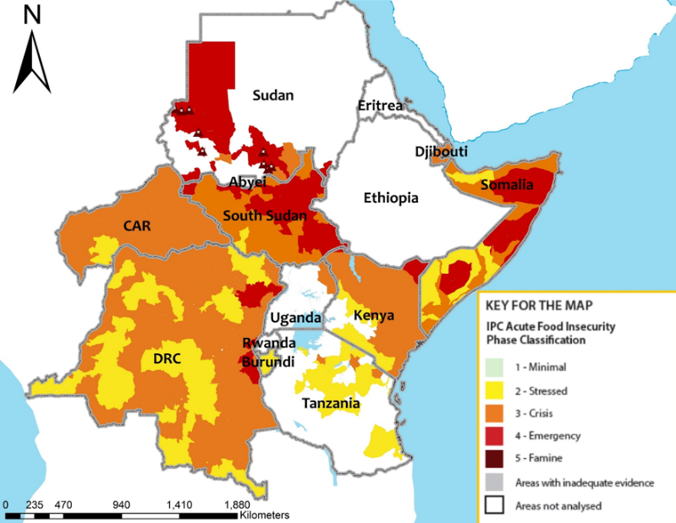
Source: IPC-GSU for East and Central Africa

Looking at the main drivers of acute food insecurity in the region, a persistent dry spell since April has affected many parts of the region, including Ethiopia, western Kenya and northern Uganda, significantly reducing prospects for crop production.
The June-September (JJAS) rainfall season, which is critical for the northern and western parts of the region, has recorded a poor start, with record-low rainfall amounts observed in June across much of Ethiopia, western Kenya, eastern South Sudan, southern Sudan, and Uganda. At the same time, the latest July-September forecast indicates an intensifying dry signal – largely attributed to El Niño – with below-average rainfall expected across Ethiopia, western parts of Kenya, most of South Sudan, Sudan and Uganda, along with above-average temperatures that are likely to exacerbate moisture deficits and increase crop water stress.
For cropping households, this is likely to result in crop failures and significantly below-average yields, reducing both food availability for household consumption and income from crop sales. According to the Food and Agriculture Organization of the United Nations (FAO), national cereal production drops by 6% in Sudan, 4% in Ethiopia and 2% in South Sudan during El Niño years. Among pastoral households, this is likely to result in severe pasture and water shortages, undermining livestock body conditions and production.
Beyond the adverse climatic conditions, conflict and insecurity remains a major driver of acute food insecurity across several countries.
In Sudan, more than three years of conflict continue to drive extreme levels of acute food insecurity, with 199,713 people expected to face Catastrophe (IPC Phase 5) through September and a risk of Famine identified in 14 areas across North Darfur, South Darfur and South Kordofan under a reasonable worst-case scenario characterised by intensified conflict, and further restrictions on humanitarian access and the movement of people and goods.
Agricultural production has remained constrained through limited access to farmland, destruction of infrastructure and high input costs. Reflecting this, FAO estimates national cereal production from the 2025|26 main season at 5.2 million tonnes, representing a 22% decline from 2024 and 19% below the recent five-year average. At the same time, supply chain disruptions have continued to put upward pressure on food prices, while widespread displacement and the erosion of livelihoods have left many with limited access to food and basic services. Exacerbating the situation is humanitarian access constraints.
In South Sudan, fighting in Jonglei has displaced more than 300,000 people within the state and neighbouring areas since December 2025, including 140,000 in Akobo county, which remains the epicentre of the violence. About 100,000 people have also fled into neighbouring Ethiopia. Humanitarian access remains constrained in several locations, cutting off many from critical assistance and contributing to further worsening the situation.
An estimated 73,306 people face Catastrophe (IPC Phase 5) across Akobo, Fangak, Nyirol and Uror counties in Jonglei state, as well as Luakpiny | Nasir and Ulang counties in Upper Nile state. A risk of Famine has been identified in Akobo and Nyirol (Jonglei) and in Luakpiny| Nasir and Ulang (Upper Nile) under a worst-case scenario of escalation of conflict, further large-scale displacement and reduced humanitarian access.
Meanwhile, the Ebola outbreak is compounding poverty rates and acute food insecurity, particularly in eastern DRC, through disruption of informal markets, cross-border trade and agricultural livelihoods. A recent rapid socioeconomic assessment by the United Nations Development Programme (UNDP) projects that the poorest 20% of households in the DRC could face a 1.76% decline in daily consumption, even if transmission remains largely contained within the DRC and Uganda.
The ongoing Middle East conflict continues to disrupt global energy and fertilizer markets, driving up agricultural production and transportation costs across all the countries. Combined with inflation and currency depreciation, these factors are reducing household purchasing power and potentially worsening food access among vulnerable populations (more information provided in the markets and trade section).

Nutrition
Nutrition outcomes across the region remained concerning, reflecting constrained access to food, inadequate infant and young child feeding practices, and limited health and nutrition services.
In Ethiopia, pockets of high levels of wasting persist. The 2026 SMART+ surveys revealed a global acute malnutrition (GAM) prevalence of 19% and a severe acute malnutrition (SAM) prevalence of 3.8% in Awsi Rasi zone, Afar region, underscoring the need for urgent life-saving interventions. In North Wollo zone, Amhara region, GAM prevalence stood at 8.6%. Between January and May 2026, 242,487 under-five children were admitted for SAM treatment across the country.
In Kenya – arid and semi-arid lands (ASALs), Kisumu, Mombasa and Nairobi – 810,871 under-five children are acutely malnourished, 202,230 of them severely so. Of particular concern are Mandera, North Horr|Chalbi in Marsabit, Turkana East and South, and Laisamis which are in an Extremely Critical acute malnutrition situation (IPC AMN Phase 5). Access to nutrition services remains limited with active outreach sites present in only 35% of hard-to-reach malnutrition hotspots recently mapped by the United Nations Children’s Fund (UNICEF).
Driven largely by worsening acute food insecurity, the number of acutely malnourished under-five children in Somalia has increased from the earlier projection of 1.85 million to 1.88 million, including about 493,000 children suffering severe acute malnutrition. At the same time, 25 hotspot areas are in a Critical situation (IPC AMN Phase 4), while Buurhakaba is in an Extremely Critical situation (IPC AMN Phase 5) and faces a risk of Famine under a plausible worst-case scenario, including a failed Gu season. Despite substantial treatment needs, service delivery remains increasingly constrained by funding shortfalls and site closures. Reflecting this, admissions to targeted supplementary feeding programmes (TSFP) and outpatient therapeutic programmes (OTP) and declined by 27% and 19%, respectively, between January and May 2026 compared to the same period in 2025.
Similarly, in South Sudan, the number of acutely malnourished under-five children has increased from 2.1 million to 2.2 million, including about 697,000 children with severe acute malnutrition. Baliet, Akoka, Luakpiny| Nasir and Ulang (Upper Nile), Abiemnhom and Rubkona (Unity), and Duk, Akobo, Fangak and Uror (Jonglei) counties and the Abyei Administrative Area are estimated to be in an Extremely Critical situation (IPC AMN Phase 5).
In Sudan, the nutrition situation continues to deteriorate, with no indication of improvement. SMART surveys conducted between January and April 2026 consistently found high to very high GAM prevalence. Of 87 surveys, 42 revealed GAM prevalence above the 15% World Health Organization (WHO) emergency threshold. Three localities recorded GAM prevalence above 30%, including Um Baru, where prevalence reached a record high of 52.9%. Darfur remains the epicentre of the crisis, with 75% of surveys conducted there revealing GAM prevalence above 15%. In Kordofan, the emergence of new frontlines is further worsening the situation, with recent surveys in Al Meiram, Al Muglad and As Sunut revealing GAM prevalence above 20%. In terms of response, 181,774 under-five children were admitted for SAM treatment between January and May 2026.

Markets and trade
The Middle East crisis is amplifying food security vulnerabilities across the region. Fuel supply disruptions have led to sharp increases in fuel prices, driving up production and transportation costs and, ultimately, food prices. In Ethiopia, diesel and petrol prices in May were 232% and 187% higher than in February, respectively; in Somalia diesel prices rose by 49% between February and April; in the DRC, fuel prices increased by around 23-24% between February and mid-May; and in Sudan, commercial petrol and diesel prices rose by 22% and 20%, respectively, in May.
Food price impacts are already pronounced in some countries. In Sudan, staple food prices increased by 5-31% in May, while the World Food Programme (WFP) local food basket rose by 14% month-on-month and by 49% year-on-year. In South Sudan, prices of wheat flour, vegetable oil and salt increased by up to 60%, 50% and 180%, respectively, in some markets, while Somalia’s imported staples increased by 11-30% and its minimum expenditure basket by 27-40%. In the DRC, maize prices in Goma rose by 49% between February and mid-May.
The crisis also coincides with a critical fertilizer procurement window (June-October), risking reduced agricultural production. In Sudan, where 25% of fertilizer imports transit through the Strait of Hormuz, disruptions are likely to affect the key southeastern producing areas, which account for much of the country’s commercial production. In Ethiopia, where 20% of fertilizer imports transit through the Strait of Hormuz, supply disruptions could affect important cereal-producing areas during the JJAS agricultural season, including western Oromia, western Amhara and Benishangul Gumuz. Meanwhile in Kenya, where 40% of fertilizer imports transit through the Strait of Hormuz, import delays have already disrupted commercial production in the central, Rift Valley, and western regions, where the main long rains extend from February to August.
Impending El Niño risks could further reduce production and exacerbate food insecurity across the region.

Displacement
As of the end of June 2026, the region hosted an estimated 16.7 million internally displaced persons (IDPs).
IDPs in the region, as of June 2026
Country | IDPs
Djibouti | 6,086
Eritrea | None reported
Ethiopia | 1,919,993
Kenya | 484,260
Somalia | 3,262,080
South Sudan | 2,067,174
Sudan | 8,805,506
Uganda | 14,853
Burundi | 92,227
Rwanda | 22,000
Tanzania | 75,000
Total | 16,749,179
Source: IOM
Sudan continued to account for the majority of the region’s IDPs, with about 8.8 million IDPs, including 2.21 million displaced before April 2023 and about 6.6 million after. This represents a 24% decline from the 11.58 million high reported in January 2025, largely reflecting increased return movements. More than 4.44 million individuals have returned to their areas of origin, including nearly 3.66 million from within Sudan and close to 0.8 million from other countries.
Beyond internal displacement, over 4.62 million people from Sudan had crossed into other countries. Of these, nearly 1.4 million had crossed into South Sudan, about 67% of whom were South Sudanese returnees.
Displacement tracking elsewhere in the region indicated continued population movement in Somalia, largely due to drought, and in South Sudan, where 26,796 people were newly displaced in May 2026 due to conflict and insecurity, particularly in Akobo county (Jonglei state) and Longochuk county (Upper Nile state).

Climate
Climate forecasts initialised by the IGAD Climate Prediction and Applications Centre (ICPAC) in June indicate an intensifying dry signal across the northern and western parts of the region.
Specifically, between July and September, drier than usual conditions are forecast over Djibouti, Eritrea, Ethiopia, western Kenya, north-western Somalia, South Sudan, Sudan and Uganda, pointing to increased risk of water stress, reduced crop yields, and declining pasture and livestock productivity. Temperatures are also forecast to be warmer than usual over most parts of the region, likely leading to increased rate of evapotranspiration.
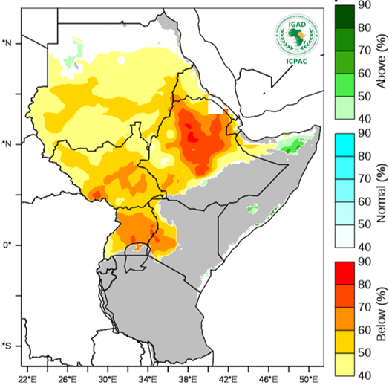
Rainfall probabilistic forecast for July-September 2026
Source: ICPAC
A review of climate drivers indicates that El Niño conditions – which are typically associated with drier than usual conditions in the northern parts of the region during the JJAS season, and wetter than usual conditions in the eastern parts during the October-December (OND) season – are present and are expected to strengthen through the end of 2026 and persist until at least January-March 2027.
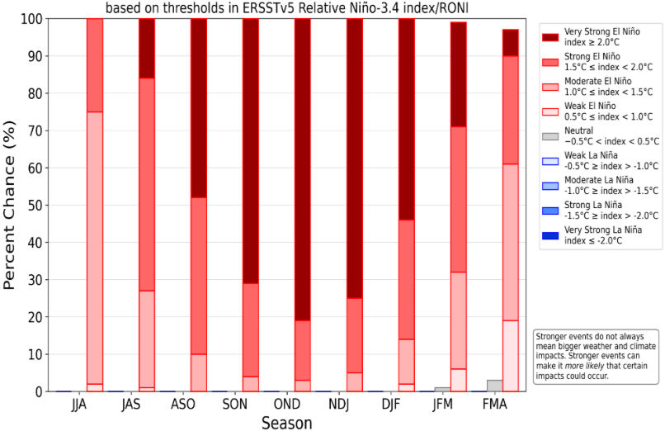
ENSO strength probability forecast, July 2026
Source: NOAA CPC

The Indian Ocean Dipole (IOD), which also influences the OND season, is expected to shift towards a positive phase in the coming months and strengthen alongside El Niño, which could intensify wetter than usual conditions in the eastern parts.
While this could favour crop and livestock production, excessive rainfall may also increase the risk of flooding, potentially leading to localised crop losses, and reduced livestock productivity through a higher incidence of vector-borne diseases.
Analysis of global climate drivers reveals similarities between the current 2026 sea surface temperatures over the Pacific Ocean and those for 1997 and 2023.

Humanitarian response
The regional humanitarian context remains highly complex. Ebola transmission continued in the DRC and Uganda. As of mid-July, the DRC had recorded 1,792 confirmed cases, including 625 deaths, while Uganda had recorded 20 confirmed cases, including two deaths. Meanwhile, countries across the region have strengthened preparedness measures and cross-border surveillance to reduce the risk of further spread.
Across Kenya, rains during the March-May rainfall season affected nearly 86,000 families, displaced about 18,500 people, and damaged crops and infrastructure. In Tana River, more than 3,100 families were displaced following heavy rains in May and early June. In Somalia, flash floods triggered by heavy rainfall on 21 June affected more than 10,600 people in Kahda and Daynille districts (Banadir region) destroying shelters, damaging sanitation facilities, and increasing health risks, particularly among IDPs.
In Sudan, escalating conflict around El Obeid in North Kordofan threatens to place hundreds of thousands of civilians at greater risk while further disrupting humanitarian access and assistance.
Although funding for Humanitarian Needs and Response Plans (HNRPs) has modestly improved in some countries, substantial gaps remain, limiting the scale and timeliness of assistance.
HNRP funding (million USD) by country, as of 10 July 2026
Country | Required | Received | Received (%)
Somalia | 852 | 179.3 | 21%
South Sudan | 1,463 | 529.3 | 36.2%
Sudan | 2,866.2 | 780.9 | 27.2%
DRC | 1,403.7 | 756.9 | 53.9%
Source: OCHA

Recommendations
The FSNWG recommends:
- Immediate, coordinated and multi-sectoral life-saving assistance in areas with populations in Crisis or worse (IPC Phase 3 or above) levels of acute food insecurity, with rapid scale up of assistance in areas with populations in Emergency (IPC Phase 4) and Catastrophe (IPC Phase 5), as well as those at risk of Famine.
- Close monitoring of the food security and nutrition situation in areas where the situation is dire and at risk of further deterioration, including parts of South Sudan and Sudan at risk of Famine (IPC Phase 5).
- Enhanced advocacy efforts for unhindered human access to facilitate the delivery of assistance and the collection of food security and nutrition data, particularly in the context of Sudan.
- Sustained nutrition interventions to prevent and treat acute malnutrition, including prioritisation of mass screening for early detection and referral, as well as expansion of integrated community case management (ICCM+).
- Close monitoring of regional market dynamics, including fuel and fertilizer supply chains, and food prices. In addition is advocacy for mitigation measures to reduce the impact of disruptions linked to the Middle East crisis on agricultural production and food security across the region.
- Close monitoring of the progression of the ongoing JJAS rainfall season, and strengthening of anticipatory action initiatives in areas forecast to experience drier than usual conditions for disaster risk reduction.
- Given the increasing likelihood of a positive IOD and the expected strengthening of El Niño, activation of preparedness and readiness measures to support anticipatory action, in respect to likely wetter than usual conditions in the eastern parts of the region.
- Enhanced Ebola surveillance, preparedness and risk communication in affected and at-risk countries.
- Collective advocacy to increase awareness of the high needs in the region, mobilise resources, and strengthen coordination among stakeholders for more effective and timely action.

Contacts
- IGAD: Charity Mumbua
(Charity.Sammy@igad.int)
- FAO: Brenda Lazarus
(Brenda.Lazarus@fao.org)

The Integrated Food Security Phase Classification (IPC) is a set of standardised tools used to classify the severity of food insecurity using a five-phase scale, that is, Minimal (IPC Phase 1), Stressed (IPC Phase 2), Crisis (IPC Phase 3), Emergency (IPC Phase 4) and Catastrophe or Famine (IPC Phase 5)
Valid through December 2025
Includes arid and semi-arid lands (ASALs) and refugee settlements
Covers 56 of 195 localities and IDP settlements
Covers Karamoja only
Covers 30 rural districts
FAOSTAT
FAO. Five things you should know about Sudan’s food crisis. April 2026
UNHCR. Renewed insecurity and rising displacement in South Sudan’s Jonglei put thousands at grave risk. June 2026
UNDP. Rapid Socioeconomic Assessment of Ebola Outbreak in the DRC. June 2026
FAO GIEWS. Agricultural production risks associated with El Niño conditions and shipping disruptions linked to the Middle East conflict. June 2026
This figure is not endorsed by the Government of Ethiopia. 1.2 million are hosted in IDP camps
ICPAC. Dual climate risk emerging. June 2026
CDC. Ebola Outbreak: Current Situation. Accessed on 13 July 2026

