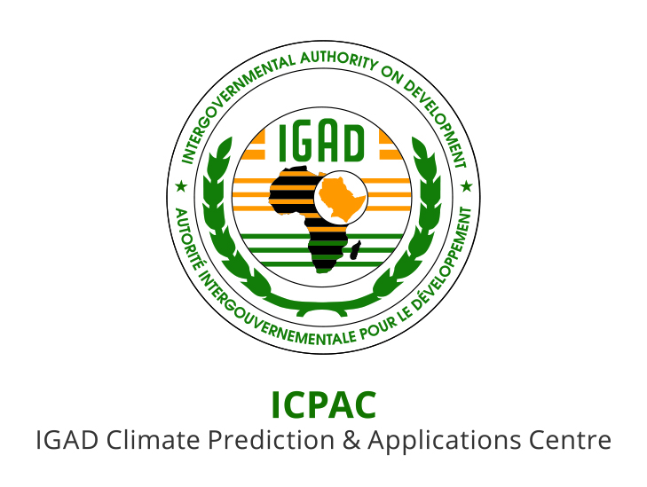

ANNOUNCEMENT

THE FIFTY SIXTH GREATER HORN OF AFRICA CLIMATE OUTLOOK FORUM (GHACOF 56) FOR OCTOBER-DECEMBER (OND) 2020 SEASON

26 AUGUST 2020

- INTRODUCTION

The Intergovernmental Authority on Development (IGAD) Climate Prediction and Applications Centre (ICPAC) in collaboration with partners is jointly organizing the Fifty Sixth Greater Horn of Africa Climate Outlook Forum (GHACOF 56) for the OND 2020 season to be held virtually through zoom on 26 August 2020. The forum will be held within the framework of the IGAD regional strategy for mainstreaming climate information in key socio-economic sectors for sustainable development. The theme of the forum will be "Climate Services amidst COVID-19 and Multiple Climate Risks”.

The virtual forum will bring together climate scientists, researchers, users from key socio-economic sectors, governmental and non-governmental organizations, development partners, decision-makers, and civil society stakeholders among others. The following users specific workshops will be conducted through zoom in parallel sessions during the forum: Agriculture and Food Security, Livestock and Rangelands, Energy and Water Resources, Health, Climate Change, conflict early warning, and Disaster Risk Management. GHACOF 56 will be preceded by an online capacity building training workshop for climate experts from the participating National Meteorological and Hydrological Services (NMHSs) from 17 to 21 August 2020, followed by a co-production workshop for Water and Agriculture sectors from 24 August 2020 as well as Pre COF workshop for all sectors on 25 August 2020. The main objectives for the Pre COF workshop for the sectors are as follows:
- Review lessons/experiences from the use of the products provided during GHACOF 55;
- Follow up on the implementation of the response strategies proposed in GHACOF 55;
- Present the consolidated objective regional climate outlook for the October to December 2020 season;
- Formulate implications of the climate forecast and response strategies for key socio-economic sectors.

- FORUM OBJECTIVES

The main objectives of the forum to be held on 26 August 2020 will be to:

    - Present the consolidated objective regional climate outlook for the October to December 2020 season;
    - Present implications of the climate forecast and response strategies;
    - Provide a regional interaction platform for decision makers, climate scientists, research scientists, users of climate information and development partners.
    - Release of the forum statement.

- STAKEHOLDERS AND PARTNERS

The key stakeholders include the GHA National Meteorological and Hydrological Services (NMHSs) and international partner organizations such as the World Meteorological Organisation (WMO); European Union; African, Caribbean and Pacific Group of States (ACP); African Development Bank; Department for International Development (DFID); WMO Global Producing Centres of long-range forecasts and the World Bank/GFDRR among others.

- WORKING LANGUAGE

The working language for the forum will be English.

- PARTICIPATION

Interested participants should register on the link provided on the ICPAC website in order to get the GHACOF 56 zoom link.

