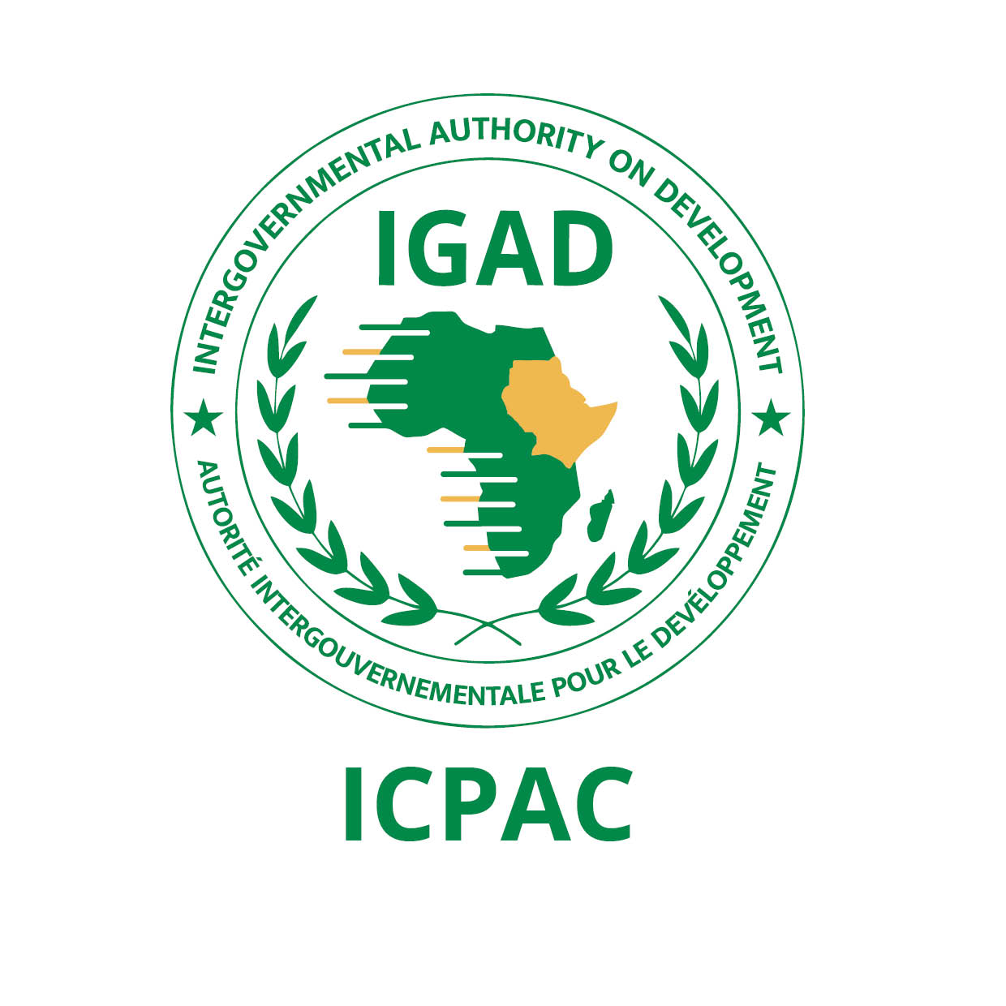
ANNOUNCEMENT

THE FIFTY EIGHTH GREATER HORN OF AFRICA CLIMATE OUTLOOK FORUM (GHACOF 58) FOR THE JUNE TO SEPTEMBER (JJAS) 2021 SEASON

27 MAY 2021

- INTRODUCTION

The Intergovernmental Authority on Development (IGAD) Climate Prediction and Applications Centre (ICPAC) in collaboration with partners is jointly organizing the Fifty Eighth Greater Horn of Africa Climate Outlook Forum (GHACOF 58) for the June to September (JJAS) 2021 season to be held virtually on 27 May 2021. The forum will be held within the framework of the IGAD regional strategy for mainstreaming climate information in key socio-economic sectors for sustainable development. The theme of the forum will be "Climate Services for Early Action”.

The virtual forum will bring together climate scientists, researchers, users from key socio-economic sectors, governmental and non-governmental organizations, development partners, decision-makers, and civil society stakeholders among others. The following users’ specific parallel workshops will be conducted virtually during the forum: Agriculture and Food Security, Livestock and Rangelands, Water Resources and Energy, Health, Climate Change, conflict early warning, Media and Disaster Risk Management. The forum will be preceded by an online capacity building and climate prediction development workshop for climate experts from the participating National Meteorological and Hydrological Services (NMHSs) from 17 to 21 May 2021, followed by co-production workshops with keys sectors from 25 to 26 May 2021.

- FORUM OBJECTIVES

The main objectives of the forum will be to:

    - Review lessons and experiences from the use of the products provided during GHACOF 57;
    - Present the consolidated objective regional climate outlook, implications and response strategies for the June to September 2021 season;
    - Provide a regional interaction platform for decision makers, climate scientists, research scientists, users of climate information and development partners.
    - Release of the forum statement.

- STAKEHOLDERS AND PARTNERS

The key stakeholders include the National Meteorological and Hydrological Services (NMHSs) in the GHA region and international partner organizations such as the World Meteorological Organisation (WMO); European Union; African, Organisation of the Africa, Caribbean and Pacific Group of States (OACPS); WMO Global Producing Centres of long-range forecasts and the World Bank/GFDRR among others.

- WORKING LANGUAGE

The working language for the forum will be English.

- PARTICIPATION

Interested participants should register on the link provided on the ICPAC website in order to get the link for the meeting.

