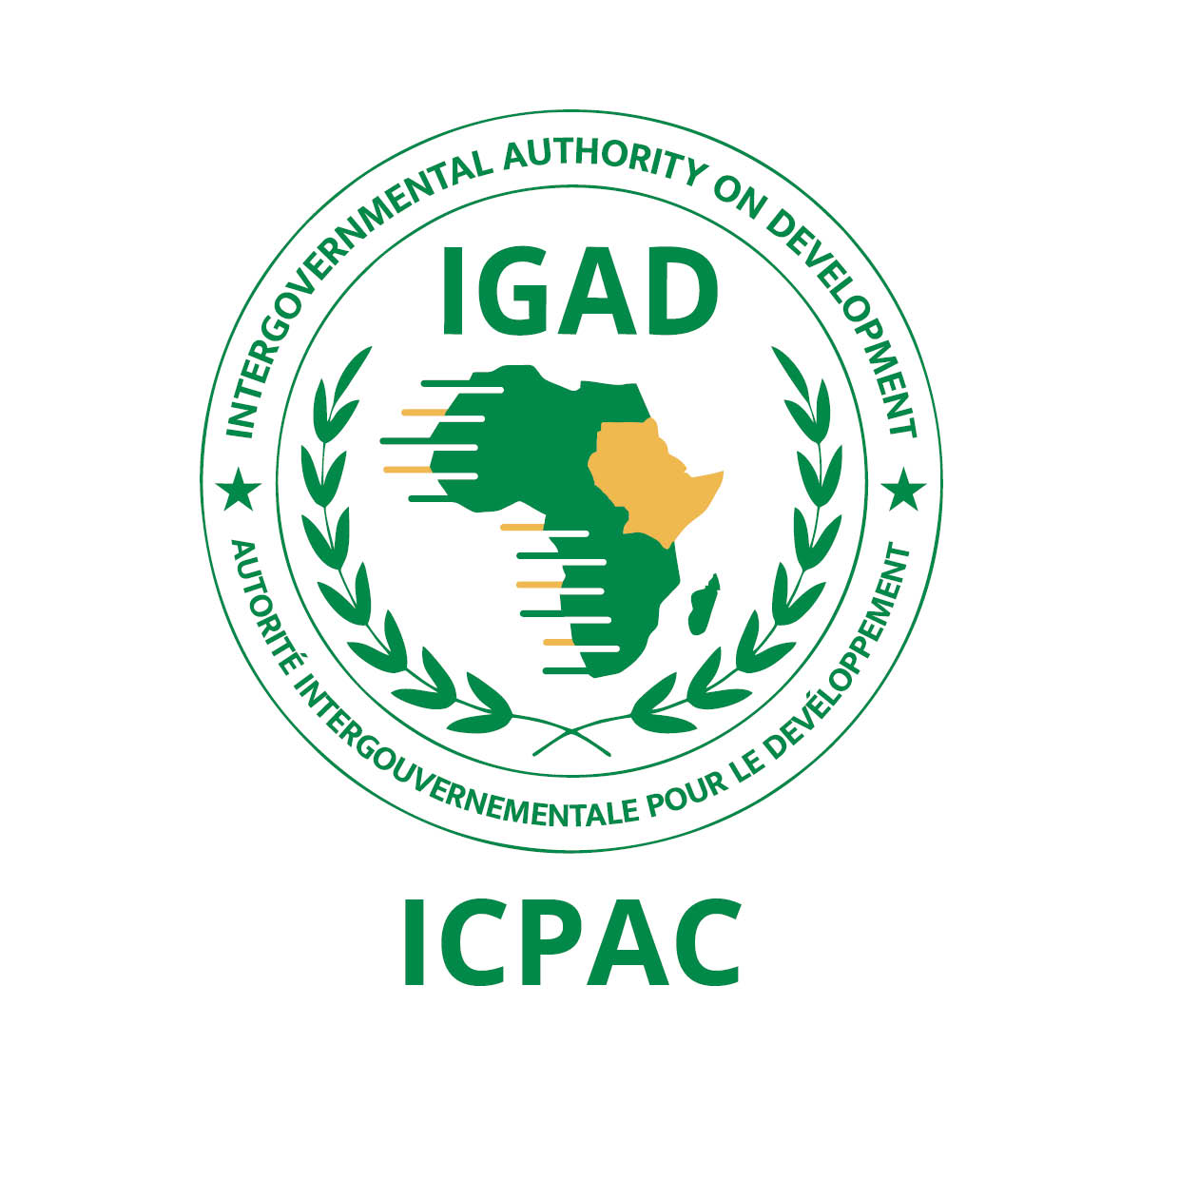
ANNOUNCEMENT

The 64th Greater Horn of Africa Climate Outlook Forum (GHACOF 64) for the June to September (JJAS) 2023 season: 24th May 2023

- INTRODUCTION

The IGAD Climate Prediction and Applications Centre (ICPAC), in collaboration with partners, is organizing the 64th Greater Horn of Africa Climate Outlook Forum (GHACOF 64) for the June to September (JJAS) 2023 season on 24th May 2023 in Addis Ababa, Ethiopia.
The forum will be held in a hybrid format (both in person and virtually) and within the framework of IGAD’s Regional Strategy for Mainstreaming Climate Services in Key Socio-Economic Sectors for Sustainable Development.
This year marks the celebration of 25 years since the launch of the first GHACOF, and the theme of this 64th edition will be: "Climate Services for Anticipatory Action”.
The forum brings together climate scientists, researchers, users from key socio-economic sectors, governmental and non-governmental organizations, development partners, decision-makers, media, and civil society stakeholders. It will be preceded by the Climate Prediction Development Workshop organized at ICPAC from 15th to 19th May 2023 and by co-production workshops with keys sectors (Agriculture, Water, Energy, Health, Livestock, Media, and Disaster Risk Management) on 22nd and 23rd May 2023.

- FORUM OBJECTIVES

The main objectives of the forum are to:
- Reflect on the performance and impacts of the March to May (MAM) 2023 season.
- Present the consolidated objective regional climate outlook for the JJAS 2023 season.
- Discuss the implications of the JJAS 2023 climate forecast and management strategies.
- Provide a regional interaction platform for decision makers, climate scientists, research scientists, users of climate information, and development partners.
- Release the outcomes of the forum and the GHACOF 64 statement.

- STAKEHOLDERS AND PARTNERS

Key stakeholders include the National Meteorological and Hydrological Services (NMHSs) of Eastern Africa (Institut Géographique du Burundi, Agence Météorologique Nationale de Djibouti, Eritrea Meteorological Service, Ethiopia Meteorological Institute, Kenya Meteorological Department, Rwanda Meteorological Agency, South Sudan Meteorological Service, Sudan Meteorological Authority, Somalia Meteorological Service, Tanzania Meteorological Authority, and Uganda National Meteorological Authority) as well as partner organizations such as the World Meteorological Organisation (WMO), the European Union, and the Organisation of the Africa, Caribbean and Pacific Group of States (OACPS).

- WORKING LANGUAGE

The working language for the forum is English.

- PARTICIPATION

Interested participants, especially from relevant socio-economic sectors, development partners, end-users of climate services, academia, researchers, climate information providers, and humanitarian agencies should register on the ICPAC website by 17th May 2023.
A link to the forum will be provided once registration has been completed.

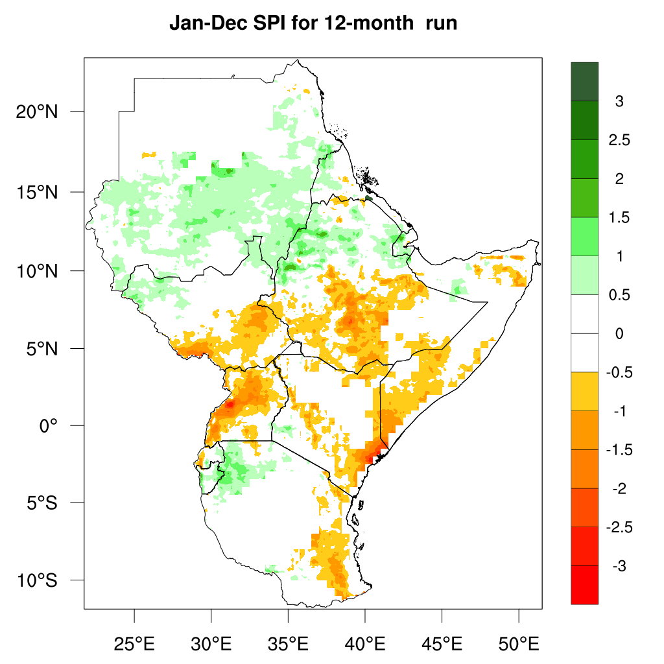
End -
12-Month SPI
(Jan-Dec 2021)

