**Report Title: Climate Change Assessment**

**Sub-title: Lannex Underground-Open Cast Section, Samancor Chrome**

**Step-by-step Guidelines for Establishing a Regional Framework**

**for Weather, Water, and Climate Services**

**May 2022**

**Step-by-step Guidelines for Establishing a Regional Framework**

**for Weather, Water, and Climate Services**

**May 2022**

Table of Contents

Table of Contents ii

List of Figures iii

1 Introduction 4

2 Background 4

2.1 What are weather, water, and climate services? 4

2.1.1 The principle of co-production with users 5

2.1.2 User tailored services and support to climate-smart decisions and their applications 6

2.2 Regional scale impacts of extreme weather, water, and climate events 6

2.3 Regional Climate Outlook Forums 7

2.4 The Global Framework for Climate Services 7

2.5 Introducing the Regional Framework for Weather, Water, and Climate Services 8

2.5.1 Objectives of the RFWWCS 9

2.5.2 Core Functions of RFWWCS 9

2.5.3 Regional stakeholders in weather, water, and climate services 11

3 Guideline for establishing RFWWCS 11

3.1 Step 1: Planning and baseline assessment 11

3.2 Step 2: Review of the RCCs and RECs 12

3.3 Step 3: RFWWCS Development 12

3.4 Step 4: Donor forum and regional action plan validation 15

3.5 Launch the RFWWCS 15

4 Conclusion 16

5 References 17

List of Figures

Figure 1: Functional components (pillars) of the GFCS 8

Figure 2: Two main objectives of the RFWWCS linking regional users and producers 9

Figure 3: The core function of the RFWWCS 10

Figure 4: Five steps for establishing RFWWCS 11

Figure 5: Sample governance structure for the development, implementation, and operation of RFWWCS (Option 1) 13

Figure 6: Sample governance structure for the development, implementation, and operation of RFWWCS (Option 2) 14

Figure 7: Collaborative implementation approach and collaborative action plan across various regional entities or institutions. 15

List of Abbreviations and Units

| CBO | Community-based organization |
| --- | --- |
| FAO | Food and Agricultural Organization |
| GFCS | Global Framework for Climate Services |
| GPC | Global producing centre |
| ICT | Information and communications technology |
| NFWWCS | National Framework for Weather, Water, and Climate Services |
| NGO | Non-governmental organization |
| NMHSs | National Meteorological and Hydrological Services |
| NSP | National Strategic Plan |
| RCC | Regional Climate Centre |
| REC | Regional Economic Commission |
| RFWWCS | Regional Framework for weather, water, and climate Services |
| RSP | Regional Strategic Plan |
| UIP | User Interface Platform |
| UNDP | United Nations Development Programme |
| UNEP | United Nations Environment Programme |
| UNESCO | United Nations Educational, Scientific and Cultural Organization |
| UNISDR | United Nations Office for Disaster Risk Reduction |
| WFP | World Food Programme |
| WMO | World Meteorological Organization |

# Introduction

The Regional Framework for Weather, Water and Climate Services (RFWWCS) is intended as an institutional mechanism to coordinate, facilitate, and strengthen collaboration among regional institutions to improve the co-production, tailoring, delivery and use of science-based weather, water and climate predictions and services by focusing on the five pillars of the Global Framework for Climate Services (GFCS).

Conceived as the regional declination of the GFCS, the RFWWCS is introduced to serve as the regional mechanism to bridge the gap between available weather, water and climate information developed by regional scientists and service providers, on the one hand, and the practical needs of regional users on the other hand. The main purpose of the RFWWCS is to provide leadership on weather, water, and climate services delivery and facilitate integration and coordination of regional institutions, enabling them to work together to co-design, co-produce, communicate, deliver, and use weather, water, and climate services within a region.

The RFWWCS will also serve to facilitate the identification of common needs of regional users for which weather, water and climate services could be co-produced at a regional level, and in turn, support National Meteorological and Hydrological Services (NMHSs) with co-production at national level. For the RFWWCS to be effective at the regional level, regional stakeholders must drive the process and design it in a manner that addresses regional needs and priorities for weather, water and climate service provision and utilization. It is envisaged that the RFWWCS for a region will be initiated and jointly led by the Regional Economic Commissions (RECs) and Regional Climate Centres (RCCs) in that region.

Hence, this publication is intended to assist the RECs, RCCs, and their supporting partner institutions and stakeholders, engaged under the five components of the GFCS, to establish the RFWWCS. The aim of the RFWWCS will be to provide leadership on weather, water, and climate services delivery by establishing a common vision and action plan for service promotion and delivery in the region; and to coordinate regional institutions, enabling them to work together to co-design, co-produce, communicate, deliver, and use weather, water, and climate services for decision-making in climate-sensitive sectors across the entire value chain. The value chain encompasses the production and delivery of weather, water, and climate services (i.e., from observations, modelling, forecasting, co-design, and service delivery), as well as stakeholder actions and outcomes, and involves the routine evaluation of associated costs and benefits.

RECs, RCCs and their supporting partner institutions can use these guidelines in their entirety, adapt them to unique circumstances in their regions or use only the parts that they find useful. The guidelines are supplemented by RFWWCS templates, comprising sample chapters and guiding narrations, to enable RECs, RCCs and their supporting partner institutions develop RFWWCS documents in a consistent manner. These guidelines also contain the RFWWCS Adequacy Assessment Checklist. The checklist will enable the regions to self-evaluate the adequacy of their RFWWCS.

Chapter 1 presents an introductory section while Chapter 2 provides the background to weather, water, and climate services. Chapter 3 details the step-by-step guidelines for establishing RFWWCS, while chapter 4 provides some concluding statements. A strategic template for developing RFWWCS is given in the appendix. Key points are provided so that readers can see important points at a glance. This document explains how to initiate and develop a functional RFWWCS that will serve as a key coordination mechanism to bring together regional, and global stakeholders needed for successful generation and delivery of co-designed and co-produced weather, water, and climate services with and for users, effectively linking weather, water, and climate knowledge with action at regional level.

It is envisaged that the outcome will be a cohesive and coordinated RFWWCS that ensures the widespread generation and use, at a regional scale, of weather, water, and climate services, to enhance the resilience of society and spur growth in the productive sectors of socioeconomic development that are sensitive to weather, and climate variability and climate change. The development and delivery of tailored services at the regional level requires significant interaction among providers, researchers and users of weather, water, and climate services, including RECs, RCCs, government, technical partners, and donors. These interactions must involve decision-makers, policymakers, regional users, weather and climate scientists, hydrologists, and sector specific experts.

It is anticipated that this publication will promote strong partnerships at the regional level that are needed for successful provision of services that inform weather-, water-, and climate-sensitive decision-making, and effectively contribute to sustainable development and resilience-building of communities and economies.

# Background

## What are weather, water, and climate services?

Weather, water, and climate services involve a range of activities related to the collection, production (processing and analysis), transmission, delivery and application of products and information, and its flow across the value chain, to a wide range of stakeholders and service platforms (WMO, 2011). These services aim to provide end-users with information in a way that assists decision-making by individuals and organizations through a process of iterative engagement and the development of tailored products that enable early action and preparedness for societal benefit.

Weather information services focus on the short-term timescales while climate information services focus on timescales going from the intra-seasonal to seasonal, annual, up to a decade. Weather and climate services often operate in tandem, and inherently impact hydrological information, hydrological services or products. Hydrological services provide information for water resources assessment and management, which is defined as the determination of the sources, extent, dependability, and quality of water resources, on which is based an evaluation of the possibilities for their utilization and control (WMO/UNESCO 1991). Relevant definitions are provided in Box 1. The seamless delivery of weather, water, and climate services is critical to ensure effective and consistent use of information for various real-world decision-making contexts[1] (according to the WMO 2011, available [here](https://library.wmo.int/doc_num.php?explnum_id=5092)).

**Box 1. Some basic definitions**

Water: Water in this guideline refers to hydrological services and does not refer to bulk water supply or infrastructure, reticulation or distribution.

Hydrological service: A service that provide information for water resources assessment, which is defined as the determination of the sources, extent, dependability, and quality of water resources and management, on which is based an evaluation of the possibilities for their utilization and control (WMO/UNESCO 1991).

Weather: The state of the atmosphere at a given time and place (generally from minutes to weeks).

Climate is typically defined as the average weather over a period (generally from years to decades). For the purposes of this report, we have used the term climate to cover time periods of months or longer.

Climate data: Historical and real-time climate observations along with direct model outputs covering historical and future periods. Information about how these observations and model outputs were generated (metadata) should accompany all climate data.

Climate information: Climate data, climate products and/ or climate knowledge.

Climate product: A derived synthesis of climate data that combines climate data with climate knowledge to add value.

Climate service: A service providing climate information in a way that assists decision-making by individuals and organizations. It requires appropriate engagement along with an effective access mechanism and must respond to user needs.

**NOTE**: For additional **definitions**, see the glossary in the report of the High-Level Taskforce for GFCS (WMO, 2011). The report can be accessed [here](https://library.wmo.int/doc_num.php?explnum_id=5092).

**Key points**

Ensure all regional stakeholders agree or are aware of the common definitions.

Different communities often have different definitions for weather, water, and climate services.

### The principle of co-production with users

One core precept of GFCS is co-production of services with users. Co-production is intended to transform data into information and then into client-tailored services, including relevant weather, water, and climate forecast-based advisory services and decision-making tools that the client can make use of. This necessitates a process of partnership-building, iterative dialogue and feedback among providers and users of the services. Effective interdisciplinary and cross-sectoral collaboration is also an important prerequisite for the transformation of data into information, and subsequently into weather, water, and climate services, blending scientific knowledge with sector-specific knowledge.

At its core, this approach postulates that weather, water, and climate information is not a service. To create a service – which, by definition, must respond to an end user need – user engagement, that is, iterative dialogue to understand and address client needs, and testing and refinement of the product based on client feedback, are compulsory. Examples of how weather, water, and climate services information can be tailored into user-driven products at a regional level are given in the following:

1. Climate factors have significant impacts on hydroelectric power, which is highly vulnerable to fluctuations in rainfall. Regional scientists are capable of simulating transboundary river runoff for a season, assisting with the reduction of climate risks associated with the negative impacts of extreme climate events on water and hydroelectric resources. Seasonal runoffs are predicted based on temperature and rainfall predictions, and current soil-moisture conditions. This information can assist water managers to make decisions on water allocations for various uses and hydropower generation planning.
2. Early warnings of risks associated with epidemics can be provided at regional scale by integrating climate information such as rainfall, temperature, and other non-climate information. The risks associated with climate-linked diseases, such as malaria, can be investigated by regional climate and health experts and further evaluated with information on population vulnerability, food security, immune suppression, and adequacy of control coverage. This can ensure that national, and local health officers have a longer lead-time to optimize the allocation of resources available to combat the disease or epidemic.
3. Early famine warning information can be developed and disseminated by regional scientist through the integration of climate predictions with food security analysis. This could help provide key information for local and national government, as well as commercial entities in planning food-grain storage, reserves, and distribution.
4. When a dam manager situated downstream a river catchment receives a seasonal forecast for above normal rainfall, the manager will evaluate the reservoir levels and determine whether early release of water is needed to avoid damage to infrastructure due to a forceful release of the sluice gates or an entire overrun of the dam.

The effective delivery of user-tailored weather, water, and climate services can only be realized through strong partnerships among regional producer and user groups, including sectoral experts, regional agencies, private sector, and academia. This will help in interpreting, tailoring, processing, and applying weather, water, and climate information and advisory services for decision-making, for sustainable development, and for the improvement of water and climate information products, predictions, and outlooks. The processing of received climate, weather and water forecast information to jointly produce, among providers and users, a relevant weather, water, and climate service is defined as co-production.

### User tailored services and support to climate-smart decisions and their applications

The following are the three fundamental guidelines for providing weather, water, and climate services:

1. **Know the user and understand what is needed:** Understand the meteorological, hydrological, and climatic elements that are relevant to the user; how the user wishes to receive information; how the user is likely to interpret the information; for what purpose the information will be used; the decision process of the user; and how the information might improve the decision-making processes.
2. **Make the information service simple, accessible, and timely:** Provide weather, water, and climate products that can be understood and readily applied by the user, along with easy access to follow-up professional advice.
3. **Ensure quality:** Provide products that have been developed with skill and an understanding of possible applications and analytical techniques, complete with proper documentation, and backed by thorough knowledge of up-to-date data availability and characteristics.

Weather, water, and climate services will be most beneficial when they are tailored to suit a particular purpose, for example:

* **Long-term policymaking**: supported by meteorological-, hydrological-, or climate- change scenario projections.
* **Medium-term decision-making**: supported through guidance provided by interannual hydrological- or climate- variability projections.
* **Short-term decision-making**: supported by weather, water, and climate forecasts or warnings for up to seasonal timescales. Short-term decision-making is relevant to a wide diversity of community interests, including agriculture and food security, fisheries, livestock, water resource management, health planning, industry, commerce emergency preparedness and response, among others.

Effective weather, water, and climate services will facilitate climate-smart decisions that will enable better management of the risks and opportunities of climate variability and change in sensitive productive sectors, for instance, in the food security, health and water resource management sectors.

Weather, water, and climate services involve a combination of:

* Accumulation of knowledge about the past, present, and future state of the hydrological, meteorological, or climatological system.
* Identification of the type and form of services involving information about water, weather, or climate and its effects that are needed within the community at large and within specific productive sectors that are particularly sensitive to climate variability and change.
* Development and delivery of advice, and provision of a range of advisory services and decision-support products based on weather, water, and climate knowledge, driven by identified needs.
* Effective uptake and application of the advice and products to help achieve the desired outcomes.

An example of impact-based forecasts and risk-based warnings systems at regional scale is the **Malaria Early Warning System for Africa –** a map showing malaria transmission risk over Africa, using a model that defines precipitation and temperature as the limiting factors of malaria incidence. More examples can be accessed in the WMO Guidelines on Multi-hazard Impact-based Forecast and Warning Services. The report can be accessed [here](https://library.wmo.int/doc_num.php?explnum_id=7901).

## Regional scale impacts of extreme weather, water, and climate events

Increases in the frequency and intensity of extreme weather, water, and climate events, and in the severity of their impacts on the natural environment and society have been observed across the globe in recent decades. The impacts of natural climate variability, coupled with greenhouse-induced climate change, result in extreme weather, water, and climate events that generate significant adverse impacts within all regions of the world.

In some regions, extreme rainfall, melting of polar ice caps and rise in sea level are becoming more common while other regions are experiencing increase in extreme heat waves and droughts. The State of the Global Climate 2021 – WMO Provisional Report[2] indicates an increase in the frequency and/or intensity of these extreme events at all regions around the world. Extreme heat waves were observed in the Western North America and broader Mediterranean regions, resulting in mass loss of mountain glaciers, and melting of ice caps. The most severe rainfall and flooding events have been recently reported in East Asia and Western Europe, breaking some national and regional records. The intensity and frequency of tropical storms and cyclones have been on the increase within several regions, resulting in significant loss of human lives and destruction of infrastructure and economic livelihoods. In Africa, climate indicators were characterized by continued warming temperatures, accelerating sea-level rise, extreme weather, and climate events, such as floods and droughts, wildfires, melting glaciers and associated devastating impacts. In South America and the Caribbean, increasing temperatures and changing precipitation patterns have resulted in increased droughts, wildfires, and hurricanes, as well as retreating glaciers. Tropical cyclones, floods and droughts are the most destructive severe weather and climate extreme events affecting the Western Pacific region recently.

In many regions, climate change is likely to increase the demand for water while depleting water resources and supply, resulting in significant challenge of meeting the needs of growing populations, sensitive ecosystems, agricultural production, energy production, and manufacturing. In other regions, water shortages will be less of a problem than increases in runoff, flooding, or sea level rise, resulting in reduced water quality and causing damage to water supply and other infrastructure.

These extreme events are threatening human health and safety, food, water, and energy security, the environment, and natural resources, with varying impacts at different regions of the world. It is therefore imperative that regional frameworks, mirroring the elements of the GFCS, be instituted at various regions to better manage the risks and opportunities arising from climate variability and change, peculiar to that region. This is with emphasis to those who are most vulnerable to such risks, by developing and incorporating science-based climate products and services into planning, policy, and practice, to enhance resilience to the impacts of extreme events, engender integration, and promote sustainable development within the region.

**Key points**

Think about the regional context: What are the most pressing needs in the region for weather, water, and climate services?

Think about the inherent climate-related threats and risks to human health and safety, food security, water supply, energy security, the environment, and natural resources within the region.

Which areas of interest are already present or covered, and which require further development?

## Regional Climate Outlook Forums

In late 1990s, an innovative process known as Regional Climate Outlook Forum (RCOF) was initiated under the WMO Climate Information and Prediction Services project in collaboration with NMHSs, regional institutions and other international organizations. RCOFs are regional platforms that brings together climate experts and sector representatives from countries in a region to provide climate prediction and information, with input from global and regional producing centres and National Meteorological and Hydrological Services, with the aim of gaining substantial socio-economic benefits in climate sensitive sectors. Over the years, RCOFs have evolved from consensus-based to objective seasonal forecast. Consensus-based seasonal forecast results from the synthesis of a wide variety of forecast information (generally, a mix of locally produced statistical forecasts and an analogue year analysis combined with global dynamical forecasts and local experience) to develop an agreed-upon consensus outlook for the season. In contrast, objectiveseasonal forecast involves a set of steps in a forecast procedure that are traceable, reproducible, and well documented and which allow quantification of forecast quality and an understanding of the variability of the regional climate.

There are currently 19 RCOFs with over 20 years of operation globally. These RCOFs are mostly coordinated and provided technical guidance by WMO RCCs (WMO, 2016). RCOFs have been mostly successful in carrying out their mandate, facilitating regional cooperation and networking and effectively demonstrating the immense mutual benefits of sharing climate information and experience. Additionally, close interaction between the providers and users of climate predictions and information has enhanced feedback from the users to climate scientists and has spurred the development of many user-specific products. A detailed report on the operations and applications of RCOFs can be accessed [here](https://library.wmo.int/index.php?lvl=notice_display&id=19693#.YeE7ff6xVD9).

The success of RCOFs notwithstanding, there is a need for regional frameworks to provide a common vision, identify key priority capacity needs, action, and resource requirements at a regional level; facilitate integration and coordination of regional institutions and enable them to work together; and support the establishment of national frameworks. Additionally, regional frameworks will serve to address funding issues and further incorporate regional users and user interface platforms in the co-design, co-production, and delivery of tailored weather, water, and climate services.

## The Global Framework for Climate Services

The GFCS is a tool to strengthen the production, availability, delivery and application of science-based climate prediction and services. It was envisioned that improvements in climate services could only be realized if relevant institutions at global, regional, and national levels work together to complement their efforts by sharing expertise and data in their respective areas of specializations and mandate to inform the development and delivery of high-quality user-oriented climate services. Therefore, the GFCS aims to enable society to better manage the risks and opportunities arising from climate variability and change, especially with a view to those who are most vulnerable to such risks, by developing and incorporating science-based climate information and prediction into planning, policy, and practice.

Weather, water, and climate services for improved adaptation outcomes hinge on a simple, yet comprehensive value chain. This value chain encompasses the production and delivery of weather, water, and climate services (i.e., from observations, modelling, forecasting, co-design and service delivery), as well as stakeholder actions and outcomes, and involves the routine evaluation of associated socio-economic costs and benefits (WMO, 2019). There are five overarching goals of GFCS:

1. Reducing the vulnerability of society to climate-related hazards through better provision of climate information and services.
2. Advancing the key global development goals through better provision of climate information and services.
3. Mainstreaming the use of climate information and services in decision-making.
4. Strengthening the engagement of providers and users of climate services.
5. Maximizing the utility of existing climate service infrastructure.

Effective development and use of weather, water, and climate services will be of great value for decision-making in many economic and social sectors. The value of using these services need to be properly assessed, by either providers or users in various application areas and geographic locations. The role of GFCS is to coordinate, facilitate and strengthen collaboration among institutions to avoid duplication of efforts. It is built through user–provider partnerships that include all stakeholders, and is based upon the following five components, or pillars (see Figure 1).

Figure : Functional components (pillars) of the GFCS

* **User interface platform (UIP)**: A structured means for users, climate researchers and climate information providers to interact at all levels.
* **Climate services information system:** The mechanism through which information about climate (past, present, and future) is routinely collected, stored, and processed to generate products and services that inform often complex decision-making across a wide range of climate-sensitive activities and enterprises.
* **Observations and monitoring:** To ensure that climate observations and other data necessary to meet the needs of end users are collected, managed, and disseminated and are supported by relevant metadata.
* **Research, modelling, and prediction:** To foster research towards continually improving the scientific quality of climate information, providing an evidence base for the impacts of climate change and variability and for the cost-effectiveness of using climate information.
* **Capacity development:** To address the capacity development requirements identified in the other pillars and, more broadly, the basic requirements for enabling any GFCS-related activities to occur.

## Introducing the Regional Framework for Weather, Water, and Climate Services

The RFWWCS is intended as an institutional mechanism to coordinate, facilitate, and strengthen collaboration among regional institutions to improve the co-production, tailoring, delivery and use of science-based weather, water and climate predictions and services by focusing on the five pillars of the GFCS.

Conceived as the regional declination of the GFCS, the RFWWCS is introduced to serve as the regional mechanism to bridge the gap between available weather, water and climate information developed by regional scientists and service providers, on the one hand, and the practical needs of regional users on the other hand. The RFWWCS will also serve to facilitate the identification of common needs of regional users for which weather, water and climate services could be co-produced at a regional level, and in turn, support National Meteorological and Hydrological Services (NMHSs) with co-production at national level. For the RFWWCS to be effective at the regional level, regional stakeholders must drive the process and design it in a manner that addresses regional needs and priorities for climate service provision and utilization.

It is envisaged that the RFWWCS for a region will be initiated and jointly led by the RECs and RCCs in that region. A regional framework will enable the appropriate coordination and collaboration mechanisms required to ensure that the GFCS pillars are effectively addressed at the regional level through identification of gaps, needs and priorities in the various GFCS components, to support the development and application of weather, water, and climate services. The development and implementation of targeted weather, water, and climate services will generally require multidisciplinary and multi-institutional collaboration to assess the climate-related risks across the spectrum of activities within the targeted sector.

**Key points**

The aim of the RFWWCS is to develop and incorporate science-based climate products and services into planning, policy, and practice.

The end point is to enhance **resilience** to the impacts of extreme events, engender **integration**, and promote **sustainable development** within the region.

### Objectives of the RFWWCS

The two main objectives of the RFWWCS (Figure 2) are the following:

* Provide leadership on weather, water, and climate services delivery by establishing a common vision, identifying key priority capacity needs, and identifying key priority action and resource requirements for service delivery in support of resilience and development within the region; and
* Facilitate integration and coordination of regional institutions and enable them to work together to co-design, co-produce, communicate, deliver, and use weather, water, and climate services for decision-making in climate-sensitive sectors at a regional level, and in turn, support the establishment of National Framework for Weather, Water, and Climate Services (NFWWCSs) across the region.

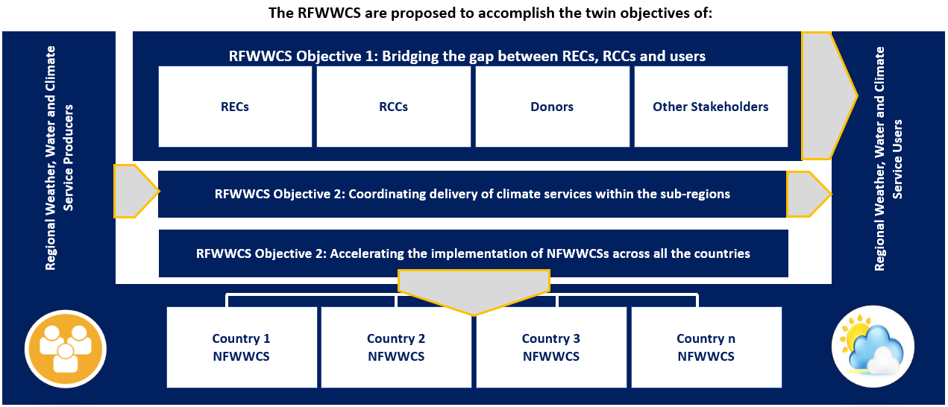

Figure : Two main objectives of the RFWWCS linking regional users and producers

### Core Functions of RFWWCS

The core functions of the RFWWCS (depicted in Figure 3) include the following:

**Objective 1 – Supporting coordinated regional weather, water, and climate services delivery in the region**

1. Leadership: Drive leadership of weather, water and climate services delivery in the region and develop a common vision and investment plan for promoting and delivering climate services in the region.
2. Research: Promote and support integrated weather, water and climate services research programmes at the regional level and encourage inter-sharing of lessons learnt and best practices.
3. Stakeholder and donor coordination:
   1. Provide a coordination mechanism to integrate the actions, investments and initiatives of complex and multiple stakeholders operating in the weather, water and climate services space in the region, state, and non-state actors, from regional to national and local levels.
   2. Serve as an integrative platform for coordinating all weather, water, and climate services-related initiatives in the region, bringing together providers, users, and enablers of weather, water, and climate services, to link weather, water, and climate knowledge with action on the ground.
   3. Ensure vertical and horizontal coordination among stakeholders in the region.
4. Readiness: Facilitate the use of protocols for assessing capabilities across the elements of the weather, water and climate value chain and readiness at regional and country level, to support weather, water, and climate services-related initiatives.
5. Enable and support the capacity development of Regional Climate Center(s) in the region, support the capacity of users to integrate and act on received services.
6. Ensure user-driven weather, water, and climate services:
   1. Identify users, continually articulate user needs for weather, water, and climate services across the 5 GFCS priority sectors for application in agriculture and food security, disaster risk reduction, water, health, and energy; as well as any other priority climate-sensitive sector deemed relevant by the region.
   2. Support user-driven weather, water, and climate research to address the knowledge frontiers salient to the needs of users in the region; and implement/strengthen operational bridges between research and operational weather, water, and climate services delivery in the region.
   3. Enable and support user specific capacity building of various users in the use of weather, water, and climate services (including the public and various spheres of government and civil societies) at the regional level, in the various climate sensitive sectors, i.e., weather, water and climate.
7. User Interface Platforms:
   1. Facilitate the establishment and operate the User Interface Platform(s), that are specific to various groups in various sectors opening regular spaces for interaction and co-production between regional providers and users of climate services as well as addressing language barriers to climate services communication.
   2. Promote development of innovative climate services dissemination models (non-internet based) to enhance climate services accessibility to marginalized communities and climate sensitive sectors; and
   3. Operate and sustain the Regional Climate Outlook Fora to ensure that they respond to user needs.
8. Policy mainstreaming of weather, water, and climate services: Actively advocate mainstreaming of weather, water and Climate Services into regional/national adaptation plans, sustainable development programs and economic development plans.
9. Monitoring and Evaluation: Assess the value and impact of weather, water and climate services on planning and adaptation decisions in the region, commission case studies, enable feedback and improvements on quality of the services provided.

**Objective 2 – Supporting the establishment of national frameworks for NFWWCS and scaling-up across the region**

1. Establish a structured approach for developing the implementation plans for the NFWWCS and the costing model for implementation in alignment with the GFCS implementation plan.
2. Support national government efforts to establish NFWWCS in alignment with relevant regional and national plans, operate national user interface platforms) and implement coordinated weather, water, and climate services.
3. Promote the development of regional and national legislation to define the institutional governance of weather, water, and climate services. For instance, the Caribbean Meteorological Organization developed the Model Meteorological Bill and Policy, which is foundational to strengthening the hydrometeorological services of WMO Member States and Territories in the Caribbean. The bill and policy are designed to support the NMHSs within the region in achieving appropriate legal mandates with well-defined roles, responsibilities, and adequate resources.
4. Actively advocate mainstreaming of Weather, Water and Climate Services into national adaptation plans and emerging broader climate change legislations, sustainable development programs and national development plans.

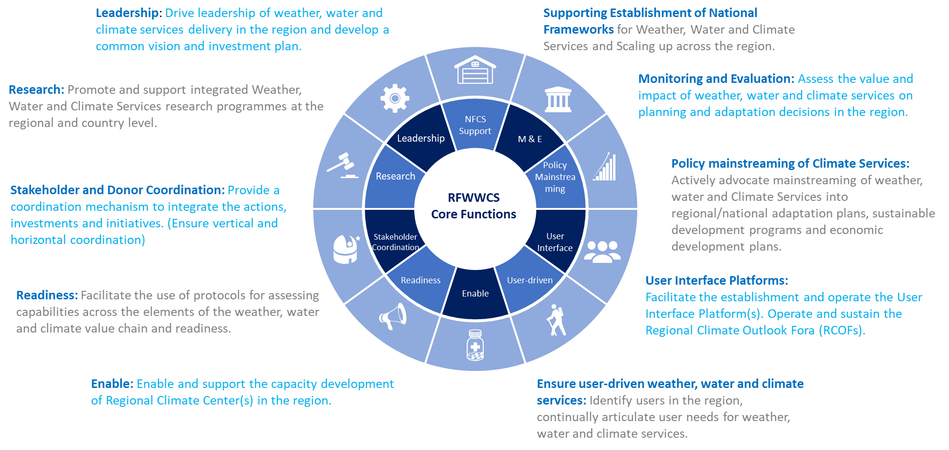

Figure : The core function of the RFWWCS

### Regional stakeholders in weather, water, and climate services

The key stakeholders in weather, water and climate services at the regional scale include RECs, RCCs, users, producers, donors, other regional or international agencies and any other entity (coming from all GFCS priority areas and components). These stakeholders are interconnected partners with complementary roles, making up the regional chain of weather, water, and climate services for linking weather, water, and climate knowledge to resilience and adaptation action. By working together, they can turn weather, water, and climate information into services, with societal value. Mapping and critically analysing the stakeholders that should be involved at the regional levels is essential for successful implementation of RFWWCS. All stakeholders with a role in the weather, water, and climate services value chain, from production, co-development through to use at the regional level, should be involved in the development, implementation, and operation of the RFWWCS.

**Key points**

Ensure all regional stakeholders have been identified.

Ensure all regional stakeholders are aware of the need for and benefits of the RFWWCS.

Different communities often have different needs relating to weather, water, and climate services.

# Guideline for establishing RFWWCS

Figure 4 gives a schematic representation of the five steps for establishing RFWWCS.

Figure : Five steps for establishing RFWWCS

## Step 1: Planning and baseline assessment

The first step in establishing RFWWCS is the planning and baseline assessment phase. This phase should involve the following activities:

1. **Establishing the RFWWCS Organizing Committee**

The establishment of an organizing committee to oversee the development of the RFWWCS is key to the smooth establishment of a functional RFWWCS. The committee should comprise of stakeholders as highlighted in Annex 1 of this Guideline.

1. **Identifying all users and stakeholders within the region**

All users and stakeholders within the region must be identified as described in Annex 1 of this Guideline. In identifying key users to engage among regional-level stakeholders, a balance is needed between high-level decision-makers and technical staff, to ensure both technical relevance and political ownership and support at the highest levels of support. Personal visits to invited partners are encouraged and explaining the background and incentive can help in ensuring buy-in from the start. All occasions of personal interactions at meetings, conferences or regional convocations should be used to engage the technical and high-level officials of all stakeholders, and current and potential clients. Before holding an initial regional consultation workshop, it is important to plan and dedicate sufficient time for these precious interactions. A brief description of the method to assess stakeholders is provided in the WMO Integrated Strategic Planning Handbook (WMO, 2016), section 3.2.1.1.3.

1. **Identifying regional threats, risks, capacities, shortfalls, and developmental needs**

As part of baseline assessment, major threats and risks relating to weather and climate variability, climate change, and design, production, transmission and delivery of weather, water and climate services within a region should be identified and assessed. Additionally, the capacity of each region to address the identified threats and risks should be evaluated, identifying capacity gaps or shortfall and developmental requirements for the region to remain resilient, towards attaining sustainable development. Refer to Box 3 for details.

1. **Defining collaboration approach, and roles and responsibilities**

The approach to stakeholder coordination and collaboration needs to be extensively discussed and validated by all stakeholders. The approach should define a structured and an integrative mechanism for coordinating all stakeholders within the weather, water, and climate services value chain in the region. The roles and responsibility of each stakeholder should be defined and documented during the planning phase; with clearly defined tasks and activities assigned where possible.

## Step 2: Review of the RCCs and RECs

The second step in establishing RFWWCS is the review of the RCCs and RECs in the region. This phase should include the following activities:

1. **Reviewing the role capacities and operational outputs of RCCs and RECs**

The roles, capacities, and operational outputs of RCCs, RECs and other regional producers of meteorological and hydrological services should be identified and assessed as described in Annex 1 of this Guideline.

1. **Assessing the baseline capacity of the RCCs and RECs to understand current needs and gaps to deliver requested impact-based forecasts and serve user needs**

A plan to evaluate the baseline capacity of RCCs and RECs should be developed, and measures to mitigate identified gaps in producer capacity and their capacity development needs should be identified. These capacity requirements may comprise institutional, infrastructure, and human resource capacity needs.

## Step 3: RFWWCS Development

The third step in establishing RFWWCS is the development of the regional framework and costed action plan. This phase should involve the following activities:

1. **Stakeholders’ consultation**

Various stakeholder consultation workshop should be organized to bring together all identified key stakeholders to draw consensus on the urgent need for improved weather, water, and climate services in the region and to improve and validate the tasks completed during planning, baseline, and gap assessment. The workshops should also critically consider key elements for development of costed action plan for implementation of the RFWWCS, focusing on areas for joint action.

The workshop should facilitate identification of appropriate mechanisms to improve and sustain the flow, co-production, and delivery of user-salient climate information for different users. Specifically, it should result in:

* Enhanced understanding of the needs for weather, water, and climate services in different user sectors.
* Improved knowledge of the existing interface and communication mechanisms and recommendations for improvements where needed.
* Clear understanding of capacity development needs to implement GFCS at the regional level.
* Strategic guidance on the institutional arrangements, partnerships and processes required to operationalize the RFWWCS at the regional level.
* identify the complementary functions of diverse stakeholders in the regional value chain for weather, water, and climate services.

The workshop should be run in a participatory fashion, to break down the institutional and often historical barriers separating the communities of practice, which must work together to link climate knowledge with action on the ground. As such, a series of participatory processes, for example games and small group activities, can be utilized, if needed, to first “break the ice” between the two communities (providers, users, partners in co-production, communicators, and boundary organizations), before each community learns what the others work on and their capacity. This may build appropriate desire for the communities to work together. Owing to the nature of the initial consultation workshop, a retreat-style format is best, whereby all participants are invited to a location where they can spend 2 – 3 days focusing on articulating a new vision for weather, water, and climate services in the region, including how they will work together.

1. **Establishing the governance framework to govern collaboration across all the elements of the value chain**

Governance structures provide the support or the framework within which authority or control can be exercised i.e., a framework of rules, relationship, processes, and systems that should guide the roles and responsibilities of various stakeholder. These structures are vital for the execution of the various action plans for the RFWWCS.

Sample schematic governance structures for the RFWWCS showing the roles of RECs and RCCs, and interlinkages among partner institutions is presented in Figure 5 and Figure 6 . The elements of the governance structure for the RFWWCS should include the following: the Host or Coordinating Entity; enabling stakeholders; enabling framework; collaborating institutions and organizations; and user interface platforms. A description of roles of each element or entity within the governance framework is provided in Annex 1 of this Guideline.

**Box 2. The Host or Coordinating Entity of the RFWWCS**

The RFWWCS is intended to serve as the regional mechanism to bridge the gap between available weather and climate information developed by regional scientists and service providers, on the one hand, and the practical needs of users on the other hand.

It is envisaged that the RFWWCS for a region will be initiated by the REC in a region, and jointly developed and implemented by the REC and RCC within that region.

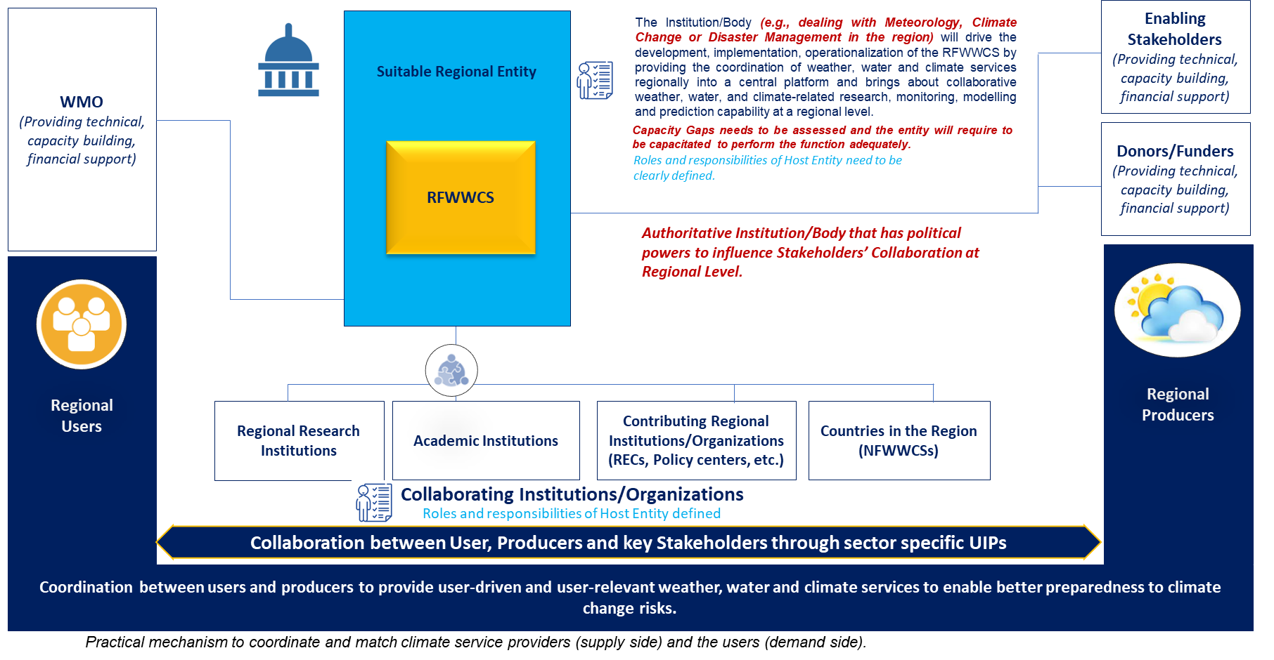

Figure : Sample governance structure for the development, implementation, and operation of RFWWCS (Option 1)

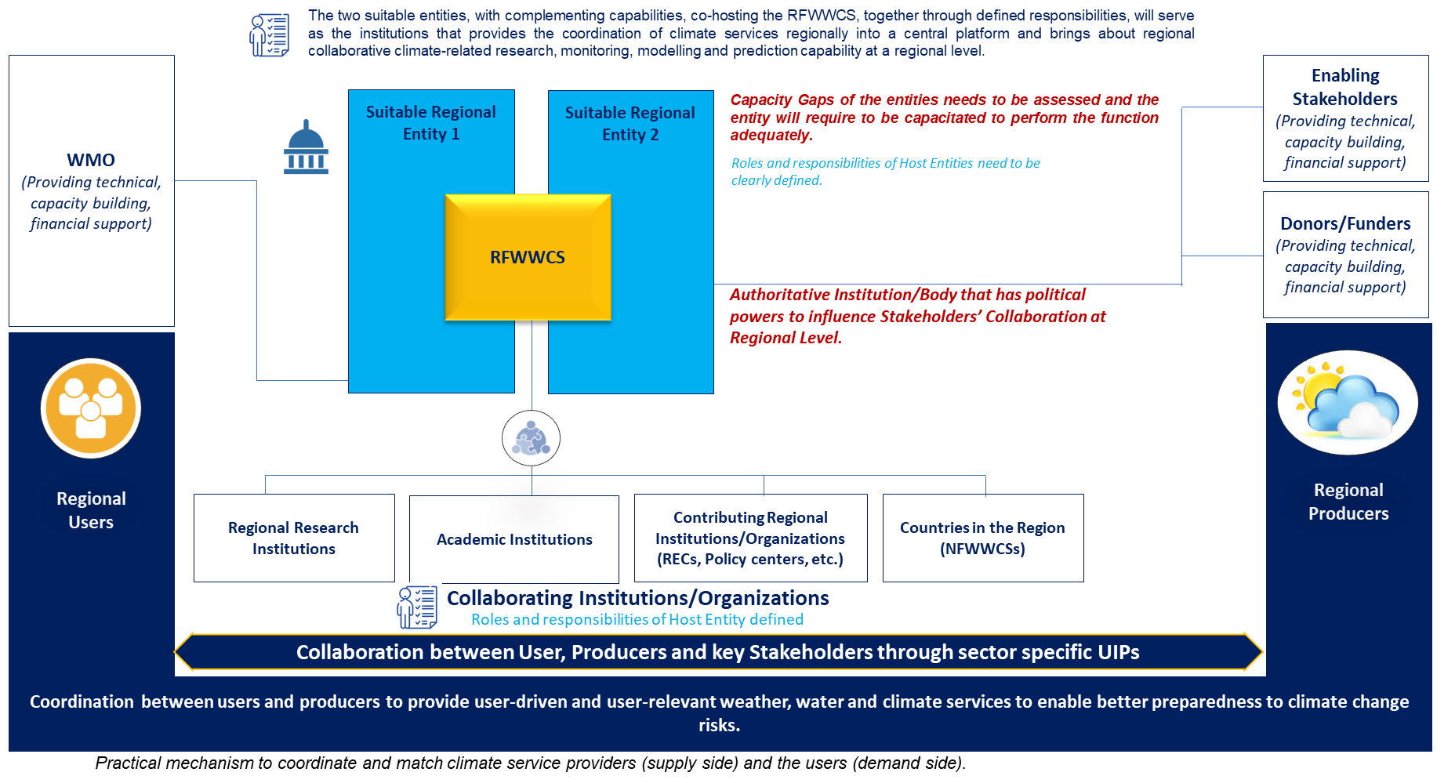

Figure : Sample governance structure for the development, implementation, and operation of RFWWCS (Option 2)

1. **Developing the regional framework and costed action plan**

Based on the results of the regional consultation workshops, the regional framework with complementing costed action plans should be developed, detailing the goals and objectives of the framework and the approaches and strategies to be implemented to achieve the goals or expected outcomes. The action plans should also detail the costs and timelines for delivering the RFWWCS and improving weather, water, and climate services delivery in the region. The planning template for RFWWCS (provided in the Appendix to this Guideline) should be used alongside the guidelines in this publication, to assist in the development of the RFWWCS.

It is Important to highlight that developing an action plan on weather, water, and climate services is a process of gap-building that captures consensus among key regional stakeholders on the needed steps and actions to improve weather, water, and climate service use at the regional scale and how to realize such improvements.

1. **Establish a collaborative implementation approach and collaborative action plan across various regional entities or institutions**

It essential to note that the successful implementation of the RFWWCS requires a coordinated and collaborative approach, as such the development of the Rational Action Plan for the RFWWCS should involve participation of various regional contributing entities and institutions. Each of these institutions should contribute by adopting relevant action items form the action plans, and integrate these into their Regional Strategic Plan and its associated action plan as shown in the model in Figure 7.

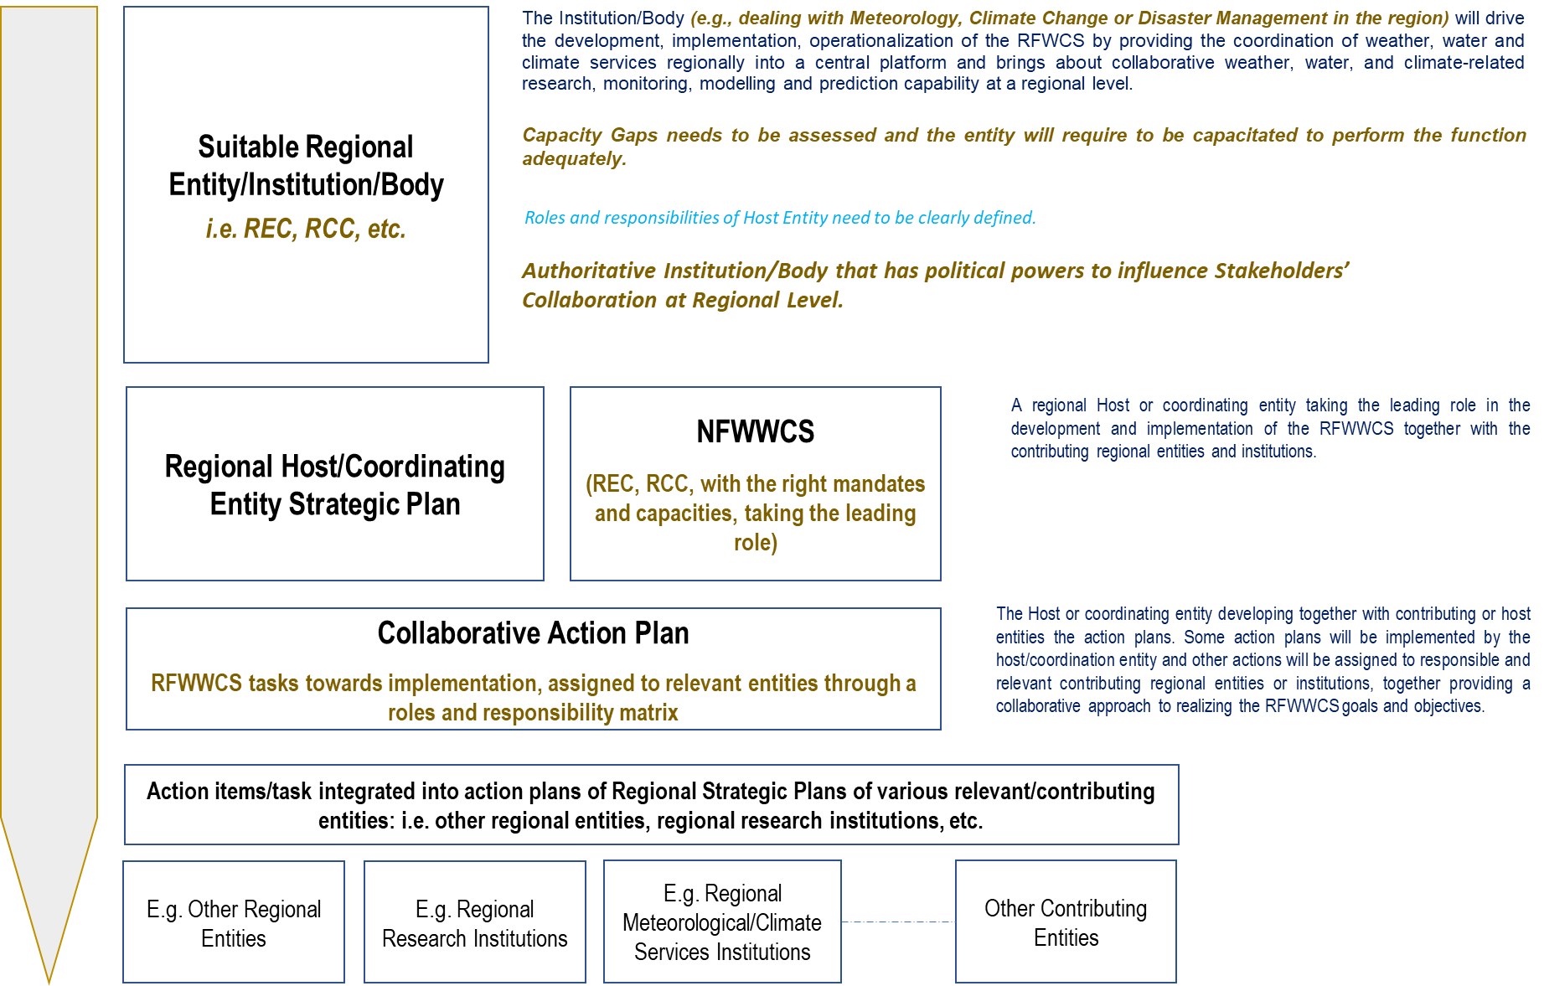

Figure : Collaborative implementation approach and collaborative action plan across various regional entities or institutions.

1. **Aligning the RFWWCS with the regional plans, policies, and frameworks**

The regional framework should be developed as a strategic component (institutional mechanism tool) that aligns with the sustainable development goals, regional development plans, regional meteorological policies, and sector-specific development plans within the region. The framework should assist RECs, RCCs and their supporting institutions to coordinate interaction amongst regional producers, users, stakeholders, and institutions along the services value chain with the aim to enhance **resilience** to the impacts of extreme events, engender **integration**, and promote **sustainable development** within the region.

## Step 4: Donor forum and regional action plan validation

The fourth step in establishing RFWWCS is organizing a donor forum to fund the regional action plans and validating the action plans. An effective partnership requires donors, funders, and partner entities to build a working consensus on objectives and strategy. This is easier when both parties have a definite strategy, clearly presented, and implemented. The effective implementation of RFWWCS is directly linked to donor funding and stakeholder participation, hence it is essential to evaluate and highlight the best suited protocol for donor and stakeholder coordination.

Where regional resources are insufficient to fund implementation of the RFWWCS, after the endorsement of regional plans, an important part of the process is to develop project proposals to mobilize additional funds for implementation of the identified priority activities in the RFWWCS. It is therefore recommended to organize a partner forum or donor round-table discussion to introduce the framework and action plan to development partners operating within the region. This could explain the funding gap, enlist support to secure funding for implementing identified priority activities and agree on steps for implementation. Once the funding for the regional action plans has been agreed, the plan will require validation from all relevant regional stakeholders.

## Launch the RFWWCS

The fifth step in establishing RFWWCS is the launching of the RFWWCS and implementing the priority activities identified. This phase should involve the following activities:

1. **Launching the implementation of the RFWWCS**

Once a regional action plan and a costed action plan, together with stakeholder validation of the RFWWCS, are finalized, it is time for the Hosting Entity / Entities to convene an event to launch the RFWWCS. This should involve all relevant stakeholders, international organizations, and development partners. The launch of the RFWWCS should not stall the implementation of some of the high-priority activities since the event can occur at any time (though preferably before the start of activities), as long as the operational beginning of coordination for the co-production, delivery and use of weather, water, and climate services in the region is initiated. This is the most significant benefit of establishing the RFWWCS.

1. **Continuous implementation, monitoring, improving, reporting, and updating of action plans**

The following actions should be continually updated for implementation of the RFWWCS:

* + - Implementing the workstream plan and work breakdown structure in each workstream.
    - Managing risks.
    - Implementing synergies and opportunities for improving return on investment.
    - Measure success and failures.
    - Delivering quick wins and tactical integration projects.

1. **Monitoring achievements, reporting success, failures, and progress**

Achievements and results should be measured based on the reporting, monitoring and evaluation protocol established in Annex 1 of this Guideline. The protocol should enable the Host Entity and Oversight Entity to continuously track and assess the progress, success, and challenges within the program to ensure that challenges and issues are managed efficiently. The success and failures of the implementation of the action plans should be reported and communicated based on the communication plan and reporting protocols (Annex 1 of this Guideline).

# Conclusion

The five steps in establishing RFWWCS are expected to be helpful to RECs, RCCs and their regional partners in weather, water, and climate service co-production and delivery, to initiate the process of establishing the RFWWCS.

The end products of the five-step approach include the following:

* A functional, cohesive, and coordinated RFWWCS, with a defined governance structure and rules of engagement to deliver on its mandate.
* RFWWCS that gives a shared vision of the stakeholders or participating institutions within the region.
* A comprehensive, actionable, time-bound and costed regional action plan to implement the RFWWCS. The costed regional action plan presents tasks to be implemented by the RFWWCS to improve weather, water, and climate services with agreed clear roles, responsibilities, timelines, and budgets.

In most parts of the world, the integration of weather, water, and climate services into regional policies and decision-making processes is still limited. Hence, the RFWWCS should play a key role by bridging the gap between RECs, RCCs and users; and developing processes and guidelines that will assist stakeholders in integrating weather, water, and climate services into decision-making to manage the risks and opportunities associated with extreme climate events.

It is expected that the RFWWCS will mobilize adequate resources to implement the activities in the regional action plan to realize the goals and objectives. This may include developing project proposals to mobilize resources. It is also expected that those involved in the RFWWCS will mobilize resources together or coordinate activities, to optimize the use of available resources and avoid duplication of efforts in parallel programmes. Regions are encouraged to derive inspiration from this publication.

# References

World Meteorological Organization, & UNESCO. (1991). WMO/UNESCO report on water resources assessment: Progress in the implementation of the Mar del Plata Action Plan and a strategy for the 1990s. Paris: WMO / UNESCO.

World Meteorological Organization, 2010a: WMO Position Paper on Global Framework for Climate Services. Geneva.

World Meteorological Organization, 2010b: WMO Position Paper on Guidelines for National Meteorological Services in the Establishment of National Climate Services. Geneva.

World Meteorological Organization, 2011: Climate Knowledge for Action: A Global Framework for Climate Services – Empowering the Most Vulnerable (WMO-No. 1065). The Report of the High-level Taskforce for the Global Framework for Climate Services. Geneva.

World Meteorological Organization, 2014: Annex to the Implementation Plan of the Global Framework for Climate Services – User Interface Platform Component. Geneva.

World Meteorological Organization, 2015: WMO Strategic Plan 2016–2019 (WMO-No. 1161). Geneva.

World Meteorological Organization, 2016a: Regional Climate Outlook Forum. Geneva.

World Meteorological Organization, 2016b: WMO Integrated Strategic Planning Handbook (WMO-No. 1180). Geneva.

World Meteorological Organization, 2020: State of Climate Services – Risk Information and Early Warning Systems. Geneva.

1. https://public.wmo.int/en/bulletin/what-do-we-mean-climate-services
2. Available at <https://library.wmo.int/doc_num.php?explnum_id=10859>